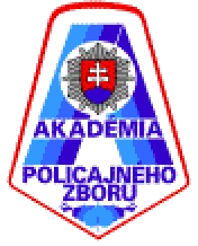

ECTS- EUROPEAN CREDIT TRANSFER SYSTEM

STUDENT APPLICATION FORM

Academic year: 2023/2024 Photo

Field of Study:

SENDING INSTITUTION

Name and full address:

Akadémia Policajného zboru v Bratislave, Sklabinská 1, 835 17 Bratislava
(Academy of the Police Force in Bratislava)

Erasmus ID code: SK BRATISL06
Institutional coordinator (name, telephone and fax number, e-mail box):

prof. JUDr. Mojmír Mamojka, PhD., tel.: +421 9610 57 003, mojmir.mamojka@minv.sk
Contact person (name, telephone and fax number, e-mail box):
mjr. Mgr. Bc. Lucia Čajkovičová, PhD. tel.: +421 9610 57 346, lucia.cajkovicova@minv.sk

RECEIVING INSTITUTION

Name and full address:

STUDENT´S PERSONAL DATA
Family name (Priezvisko): |  |  | First name (s):
Date of birth: (Dátum narodenia):
Place of Birth (Miesto narodenia):
Sex (Pohlavie): |  | Nationality (Národnosť):
E-mail:
Telephone number (incl. country code):
Permanent address (Trvalé bydlisko):

Student´s signature:

