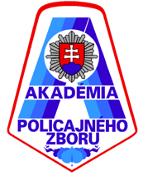
POLICE ACADEMY IN BRATISLAVA
DEPARTMENT OF INVESTIGATION

R E G I S T R A T I O N
for scientific conference with international participation
„Pharmaceutical Crime – A Threat to Europe“

I AM SIGNING TO ATTEND
the above cited scientific conference with international participation,
held on 24th April 2018 on the grounds of the Police Academy in Bratislava

(RANK, ACADEMIC TITLE) NAME, SURNAME:

ORGANIZATION / INSTITUTION:

FORM OF PARTICIPATION:
ACTIVE - PASSIVE
TITLE OF ACADEMIC PAPER PRESENTED:

BRIEF ANNOTATION:

FOOD PROVIDED BY ORGANIZER:
Lunch (24th April 2018) YES - NO

CONTACT (sent filled out registration form to):
JUDr. Juraj Drugda, PhD.
 juraj.drugda@minv.sk
 09610 57 468; +421/09610 57 468

